WikiBhashaBeta

User GuidE

Table of Contents

[About this guide 2](#_Toc275099467)

[Conventions used in this guide 2](#_Toc275099468)

[Versioning Information 2](#_Toc275099469)

[1.0 WikiBhasha beta 3](#_Toc275099470)

[1.1 WikiBhasha beta Availability 3](#_Toc275099471)

[1.2 Installing WikiBhasha beta (other modes) 4](#_Toc275099472)

[As an Extension (Will be available as an extension, only after review and approval) 4](#_Toc275099473)

[As a user-script from the Wikipedia user “WikiBhasha.MSR” 4](#_Toc275099474)

[As a Bookmarklet In Internet Explorer 4](#_Toc275099475)

[As a Bookmarklet In Firefox 4](#_Toc275099476)

[2.0 WikiBhasha beta Workflow 5](#_Toc275099477)

[2.1 The WikiBhasha beta Interface 5](#_Toc275099478)

[2.2 Invoking WikiBhasha beta on a Wikipedia Article 6](#_Toc275099479)

[2.2.1 Starting with a Target Language article 6](#_Toc275099480)

[2.2.2 Starting with an English article 6](#_Toc275099481)

[2.3 The **Collect** Step 7](#_Toc275099482)

[2.4 The **Compose** Step 8](#_Toc275099483)

[2.5 The **Submit** Step 9](#_Toc275099484)

[3.0 Other Features of WikiBhasha beta 10](#_Toc275099485)

[3.1 Search 10](#_Toc275099486)

[3.1.1 Visited Topics 10](#_Toc275099487)

[3.2 Collaborative Translation Framework (CTF) 11](#_Toc275099488)

[3.3 Scratchpad 11](#_Toc275099489)

[3.4 Wikiformat Mode 12](#_Toc275099490)

[3.5 Feedback 12](#_Toc275099491)

# About this guide

This user guide is intended for users of the WikiBhasha beta application on Wikipedia. The guide briefly clarifies the purpose and the basic workflow of the WikiBhasha beta application & its usage.

### Conventions used in this guide

|  |  |
| --- | --- |
| Term | Meaning |
| Source Language | In the context of sourcing and translating content, Source Language refers to the language of the Wikipedia from which you are sourcing content. In WikiBhasha beta, source language is English. |
| Target Language | The language in which you want to contribute content to Wikipedia. For example, if you want to contribute to a Japanese Wikipedia, then Japanese is the target language. |

### Versioning Information

|  |  |  |
| --- | --- | --- |
| Date | Who | Version Remarks |
| 17 Oct 2010 | WikiBhasha.MSR | Initial version when WikiBhasha was released on MediaWiki |
|  |  |  |
|  |  |  |
|  |  |  |
|  |  |  |
|  |  |  |
|  |  |  |
|  |  |  |

# 1.0 WikiBhasha beta

WikiBhasha beta is an extension that helps a community of users to create multilingual content in their Wikipedia, leveraging existing content from other Wikipedias. This extension manifests as a simple and intuitive user interface layer that stays on the target language Wikipedia article that is being created or enhanced through it, for the duration of the user session. At the end of the session, all content created or modified are submitted to the target language Wikipedia.

The UI layer implements a simple 3-step process helping the user in (i) gathering content from source language Wikipedia, (ii) composing the target language Wikipedia article, and finally, (iii) submitting new content to the target Wikipedia. The UI layer integrates content discovery, linguistic and collaborative services, transparently.

Though WikiBhasha beta extension is architected to be transparent with respect to languages of the source and target Wikipedias, the beta version focuses on leveraging the large English Wikipedia content primarily, for enhancing the content in non-English Wikipedias. Hence, WikiBhasha beta currently supports all translation pairs in Bing Translator (<http://www.microsofttranslator.com>), in which the source language is English. WikiBhasha beta currently tested on Internet Explorer (7 or above) on Windows XP, Windows Vista & Windows 7 and on Firefox (3.5 or above) on Windows and Linux (Fedora 11 or above).

Please ensure that you comply with Wikipedia norms for all content contribution to Wikipedia.

## 1.1 WikiBhasha beta Availability

Currently WikiBhasha beta is open-sourced as a MediaWiki Extension and will have to go through the review and approval process before it is available as an extension.

Till the extension is approved, temporarily WikiBhasha is available as a user-script in Wikipedia from ‘WikiBhasha.MSR’ user, and also as a bookmarklet from an external WikiBhasha home page (<http://www.WikiBhasha.org>). Please see the installation section for details.

## 1.2 Installing WikiBhasha beta (other modes)

### As an Extension (Will be available as an extension, only after review and approval)

WikiBhasha beta is currently open-sourced as a MediaWiki extension. We will work with the open source developer community to get this extension reviewed and approved for Wikipedia.

For now, users could use WikiBhasha as a Wikipedia user-script or as a bookmarklet from www.WikiBhasha.org.

### As a user-script from the Wikipedia user “WikiBhasha.MSR”

Those users who have Wikipedia login credentials may install WikiBhasha beta as follows. However, note that you need to install the user-gadget in each of the language Wikipedia’s you may be interested in.

1. Log in to Wikipedia. (You need to create an account on Wikipedia if you do not already have one.)
2. In every language Wikipedia that you are interested in:
   1. Visit **my preferences**, and click on the **Appearance** tab.
   2. Edit your “Monobook.js” or “Vector.js” file (based on your preference) and add the following:

|  |
| --- |
| importScriptURI('http://en.wikipedia.org/w/index.php?title=User:WikiBhasha.MSR/WikiBhasha.js&action=raw&ctype=text/js'); |

Please save your changes and reload your page to see the script added to your profile. You should see WikiBhasha in the left side as a menu item, and on Edit page as a button (as below):

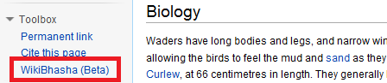 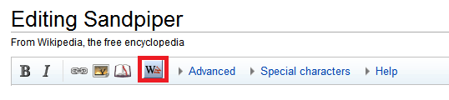

|  |  |  |
| --- | --- | --- |
| As a Bookmarklet In Internet Explorer **Adding a Bookmarklet to Favorites:**  Make sure the ‘Favorites Bar’ is visible in Internet Explorer. If it is not visible, on the **View** menu, point to **Toolbars** and then click **Favorites Bar**.  In WikiBhasha beta homepage:   1. On the **Installation** tab, right-click the **WikiBhasha beta** link and click  **Add to Favorites**. 2. On the **Add a Favorite** window, in the **Create in** list, select **Favorites Bar**. 3. Click **Add**.     The Internet Explorer Favorites bar now has a new WikiBhasha beta bookmarklet. |  | As a Bookmarklet In Firefox **Adding a Bookmarklet to the Bookmarks Toolbar:**  Make sure the ‘Bookmarks Toolbar’ is visible in Firefox. If it is not visible, on the **View** menu, point to **Toolbars** and then click **Bookmarks Toolbar**.  In WikiBhasha beta homepage:   1. On the **Installation** tab, right-click the **WikiBhasha beta** link and click  **Bookmark This Link**. 2. On the **New Bookmark** window, in the **Folder** list, select **Bookmarks Toolbar**. 3. Click **Save**.     The Firefox Bookmarks toolbar now has a new WikiBhasha beta bookmark. |

# 2.0 WikiBhasha beta Workflow

The WikiBhasha beta workflow for contribution to a Wikipedia is in three Steps – Collect, Compose & Submit.

The **Collect step** is meant for identifying appropriate content from English Wikipedia (say, from the *Tiger* article) for enhancing the target language Wikipedia article (say, its inter-wiki-linked *Panthera Tigris* article in Spanish Wikipedia). For example, the English Wikipedia article may contain sections (say, *Conservation Efforts*)that that may be missing in the Spanish article. Once such content is identified, you may correct the default translations (in target language) to make the content ready for enhancing the target article. You may use the search mechanism to identify more source content from multiple articles.

In the **Compose step**, you focus on composing a new target language article or enhance an existing article (say, *Panthera Tigris* in Spanish Wikipedia), with the content sourced in the collect step. An editable pane is provided, with which you can create the new article, or enhance the existing one, by moving the [translated and corrected] content into pane). In addition to moving the sourced content, you may rearrange, modify or rewrite the moved content, or add new material, to get your contribution to the target language article right.

The **Submit step** puts you in the edit page of the target language Wikipedia article you were working on. The edit box would contain the material you worked on in the compose step. You may use the Wikipedia edit page for any final edits, preview or submission to target language Wikipedia.

## 2.1 The WikiBhasha beta Interface

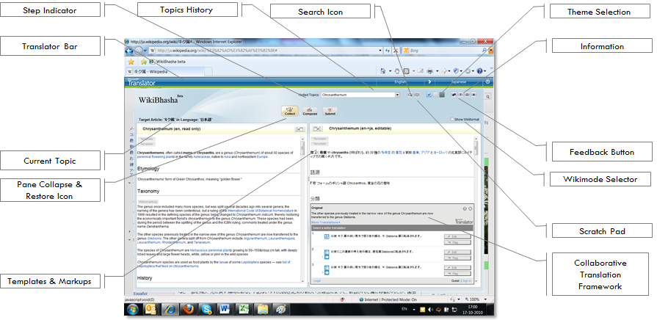

## 2.2 Invoking WikiBhasha beta on a Wikipedia Article

WikiBhasha beta may be invoked only on a Wikipedia article - either on the English or one of the supported target language Wikipedias.

### 2.2.1 Starting with a Target Language article

Consider that you want to enhance the content of Japanese Sandpiper article. You are currently on the Japanese Wikipedia article on *Sandpiper*. Clicking on the **WikiBhasha beta** script on the Wikipedia page or the bookmarklet button on your browser toolbar, opens the WikiBhasha beta application as an edit layer on the top of the Japanese Wikipedia article. You are directly taken to the Collect step.

### 2.2.2 Starting with an English article

1. Click the **WikiBhasha beta** button on your browser toolbar, when on an English Wikipedia article.  
   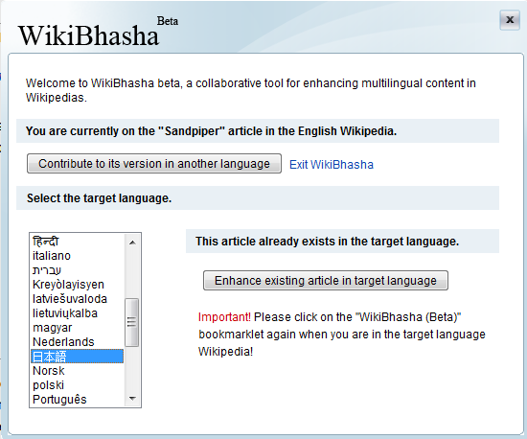
2. Click **Contribute to its multilingual version**.
3. In the **Select Language** list, select Japanese.
4. Follow one of the following sub-steps:
   1. If a Japanese Wikipedia article on Sandpiper already exists, then your browser will display that article in the Article Title box. Click **Contribute to Japanese article**.
   2. If an article does not already exist in the target language, you will be prompted to type an Article Title and click **Create Japanese article**. A default name would be provided as a suggestion.  
      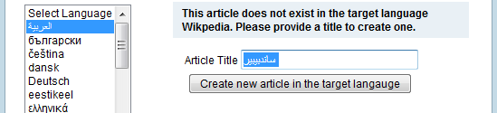
5. In either of the above, you would be put into target language Wikipedia article (normal mode for existing article, or edit mode for new article). While the script will invoke WikiBhasha automatically on the target article, the **WikiBhasha beta** bookmarklet may have to be clicked once *again*.

## 2.3 The **Collect** Step

In Collect step – the two pane display of WikiBhasha beta shows the source article in English on the left pane, and the machine translated target language version of the articleon the right pane. Note that the content is displayed in a simplified manner, fully preserving underneath the wikimarkups in the text; the user may switch between this view and fully wikimarkedup view by checking the **Show Wikimarkup** box.

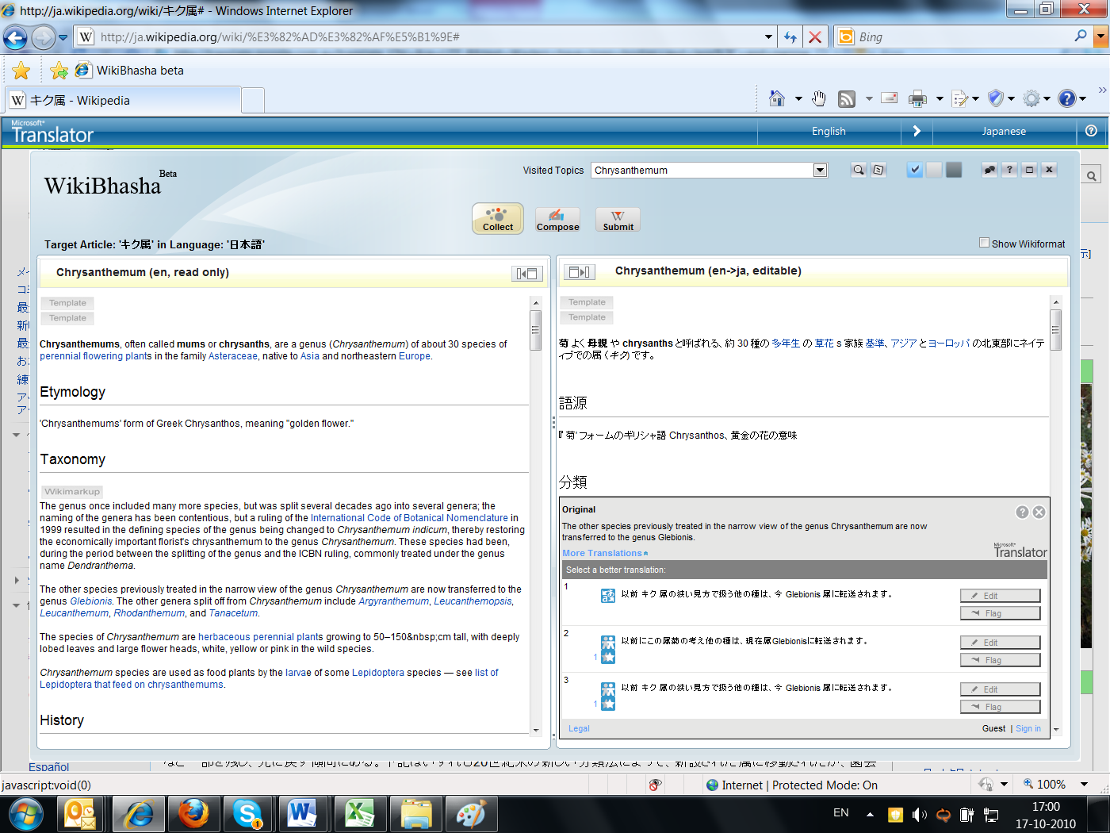

This pane supports synchronized scrolling between the left and right panes. Highlighting (by hovering over it) a sentence in either pane, results in the corresponding sentence being highlighted in a synchronized manner in the other pane as well.

The content in the right pane is editable. You can directly edit content in the right pane (in the target language). We assume you have the appropriate mechanism for typing in non-English languages.

WikiBhasha beta uses the Collaborative Translation Framework (CTF) to provide alternatives for the target language translations for a given source language sentence. You may also use CTF for correcting a sentence. Any changes through CTF would be available for all users of WikiBhasha beta, instantly. For more on CTF, read Section 3.2.

You can search for other articles from which you may source content. For more on Search, read Section 3.1.

## 2.4 The **Compose** Step

In Compose step, a two pane display shows the translated [and potentially modified in the first step] English article in the left pane. Any existing target language content from the target language Wikipedia is displayed in the right pane. Note that the content is displayed in a simplified manner, fully preserving underneath the wikimarkups in the text.

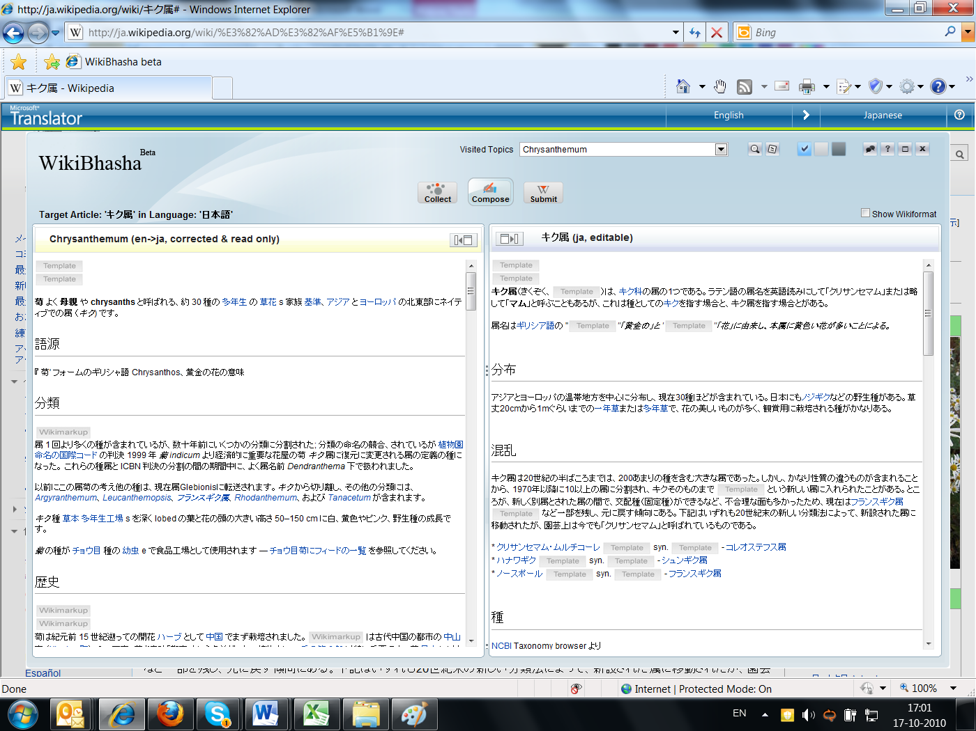

If target language Wikipedia does not currently have a corresponding article (it is being created in this session), then a **Bring the translated & corrected source content** message is displayed in the right pane. Clicking **Yes**, to copy the entire content from the left pane to the right pane.

You can selectively copy and paste content from the left pane to the right pane, using the Ctrl + C key combination to copy, and Ctrl + V combination to paste content. You can also highlight a block of text using the keyboard or mouse, and then drag and drop the block of text from the left pane to the right pane using the mouse.

You can directly edit content in the right pane (in the target language), for re-organizing, rewriting existing content or adding new content.

You can also search for other topics from which you want to select content to contribute to the target language. For more on Search, read Section 3.1.

## 2.5 The **Submit** Step

In Submit step you are put directly into the target language Wikipedia, in the edit page of the article you are enhancing or the new article you are creating. The content composed in the right pane of Compose step is available (with all the wikimarkups) in the Wikipedia edit box. You can make any final editorial changes in the edit box.

It is highly recommended that you do a Wikipedia preview (**Alt-P**) to make sure the article displays correctly) and resolve any conflicts (such as, redlinks). You should conform to the norms of the target language Wikipedia before submission (**Alt-S**).

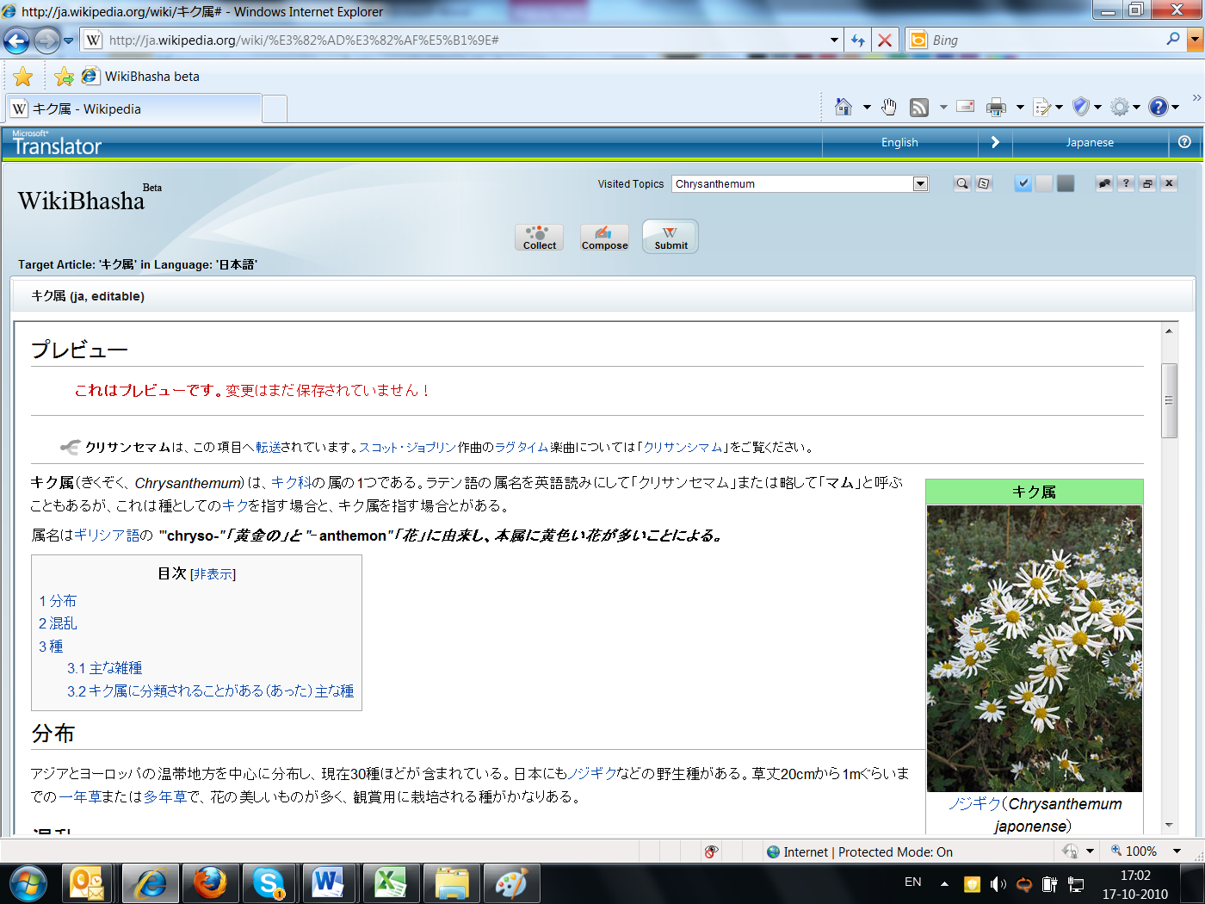

Now, all the changes you made to the target language article is now part of Wikipedia. Congratulations!

# 3.0 Other Features of WikiBhasha beta

## 3.1 Search

Use the **Search tool** to explore source or target language Wikipedias for other articles from which you identify/source content to enhance target Wikipedia article. The search tool displays relevant articles from both the source and target language Wikipedias, as returned by the default Wikipedia search mechanism.

1. Click the Search button to open the Search pane.
2. Type the search keyword and click the Search button in the Search pane.  
   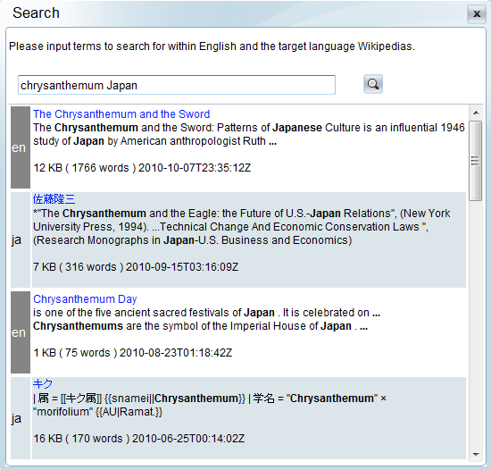
3. Click the title of a search result, to open its corresponding topic.

If you select a search result that is in the source language, the topic will be opened in the two pane display of the Collect Step (Section 2.3).

If you select a search result that is in the target language, the topic will be opened in the two pane display of the Compose Step (Section 2.4).

Note: If you open a target language article via search, Collect Step is not available for that topic.

### 3.1.1 Visited Topics

The **Visited Topics** list displays a list of all previously visited topics in the user session. Select any topic from the list to switch to that topic. If you select a topic in the source language, the topic will be opened in the Collect step. If you select a topic in the target language, the topic will be opened in the Compose step.

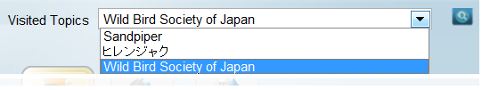

## 3.2 Collaborative Translation Framework (CTF)

In both the Collect and the Compose steps, a collaborative mechanism – Collaborative Translation Framework (CTF) – is available. CTF is a collaborative cloud service provided by Microsoft Translator, which makes available alternative translations (provided by other users) for the highlighted sentence.

1. In Collect step, on the right pane, a CTF pane is displayed for the highlighted sentence.  
   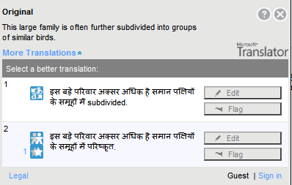
2. Click **More Translations** for alternatives to the default translation (provided by other users).  
   Trans_Auto.jpg denotes default automatic machine translation, and Trans_Collab.jpg denotes collaborative translations.
3. Select one of the available translations from the list to replace the current sentence in the article with that sentence. You can use the **Edit** button shown against a translation to edit that sentence.
4. When done with editing, click **Submit**.

**Submit** will close CTF, and the version as changed/corrected by you would replace the version on which CTF was invoked. In addition, your version of the translated sentence is added as one of the alternatives through CTF to all subsequent users.

## 3.3 Scratchpad

1. Click the Scratchpad button to display the Scratchpad pane.  
   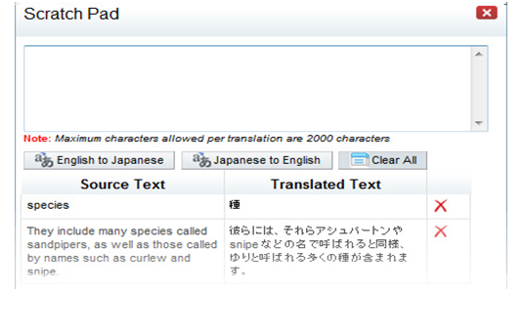
2. The above window is opened, which could be used as a scratch pad for translations. You can use the Ctrl+C / Ctrl+V key combinations to copy-and-paste text from/to WikiBhasha panes (or any other source).

## 3.4 Wikiformat Mode

So far, all the edit features of WikiBhasha beta described had been shown in a simplified mode. By click the **Show Wikiformat** check box you can enable the Wikimarkup mode, in which the content will be displayed in the native wikimarkedup format (with all the wiki markups), just as you would see in the Wikipedia editor. You are free to work in this mode as well, or toggle back to simplified mode by checking **Hide Wikiformat** check box.

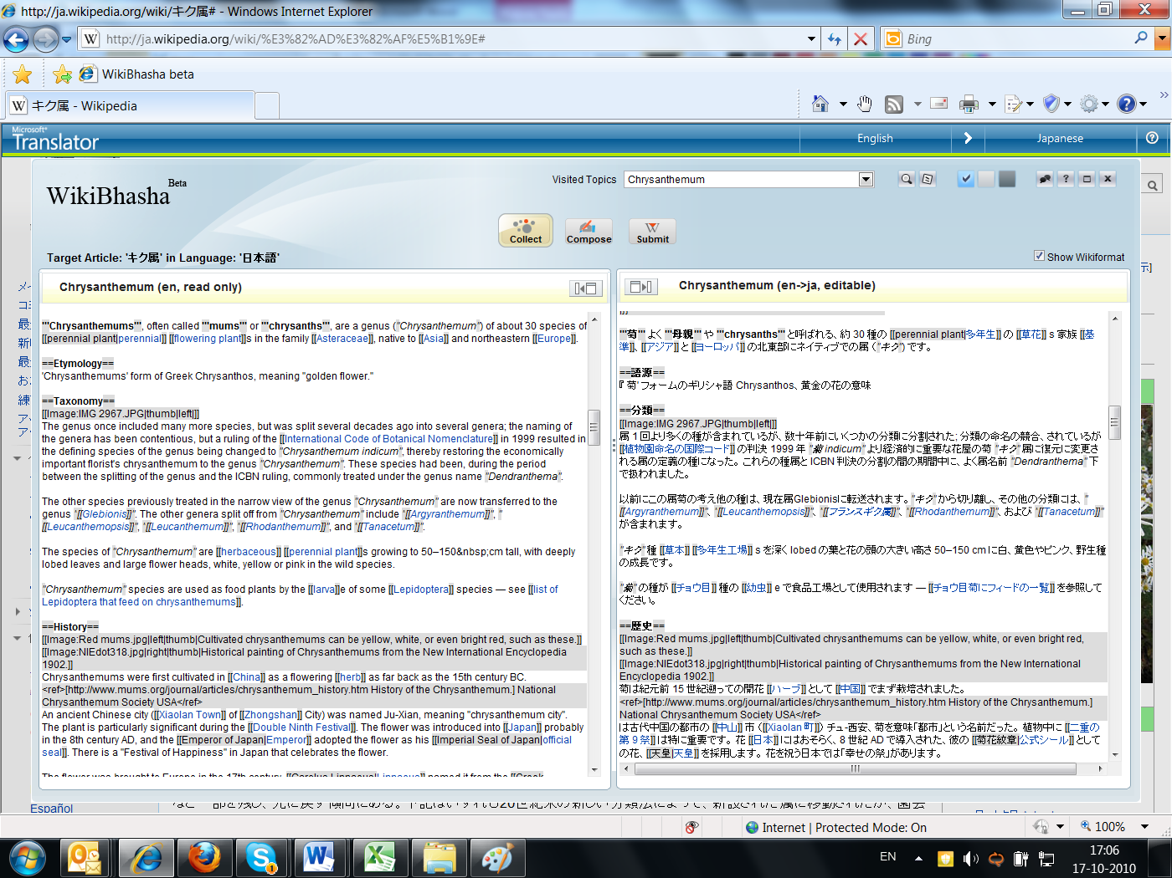

## 3.5 Feedback

Clicking the Feedback button on the top, invokes the following feedback box, which may be used for providing feedback and requests to the WikiBhasha beta team. You can send the feedbacks as email, or by using the discussion forums in <http://research.microsoft.com/WikiBhasha> page or in Wikimedia discussion pages.

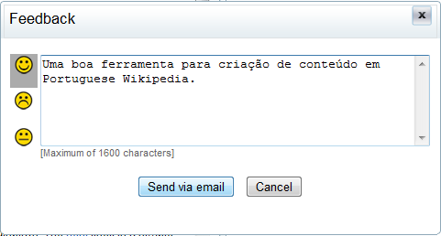

That’s all, Folks! We hope that this application is useful, and with your feedback it may get even better!